Pre model exam

1.write ac++ program to create a class called cae that has private member function company,model,yea.implicent to set values.

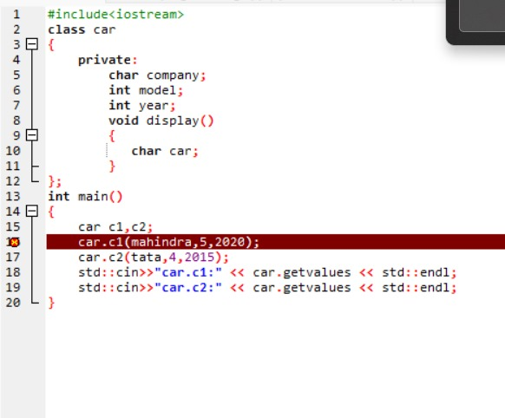

2.create a class named programming while ctreating an object of this class ifnothing is passed to it,then the message “I Like programming language “shold be printed .if something string is passed to it then “I Like programming” should be printed.

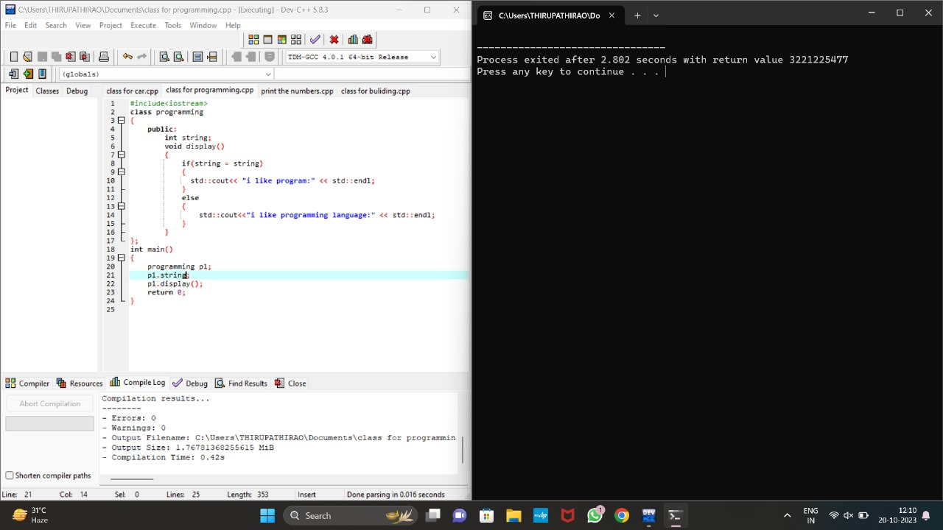3.print the number in the following mannaer

1

1 2

1 2 3

1 2 3 4

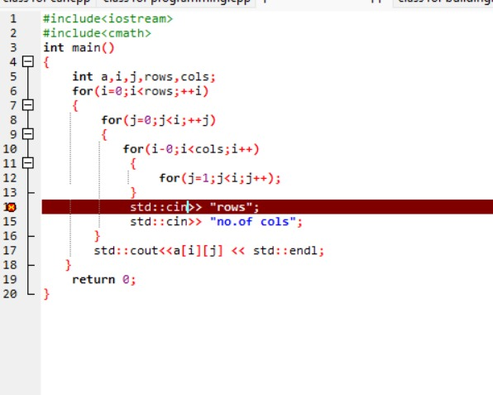

4.craete aclass building that contains member function no of units consumed,customer name,

Create aclass that is derived from the base class building that contains the member funtions no of floors and no.of plots.if no.of floors is more than 10 (or) behond 3 plots units rate is 10/-.and if no.of floors is less than 10 (or) less than 3 plots units rate is 5/-.

